**SAMPLE GUIDE:**

1. Created a project “SampleProjectForTibUnit”

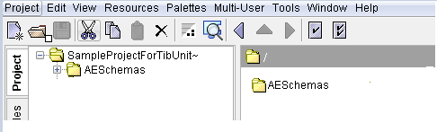

1. Created a Soap service, a rest service and some basic processes.

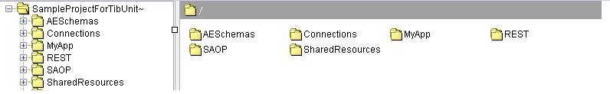

1. Imported the TibUnit Projlib.

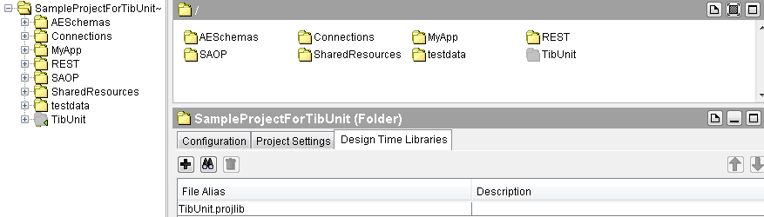

1. Created a folder “TibUnitTests” at root level.
2. Created two folders named “testdata” and “report” in C drive.
3. Inside TibUnitTests folder, created 3 folders, One for SOAP test cases, one for REST test Cases, and one for general processes.

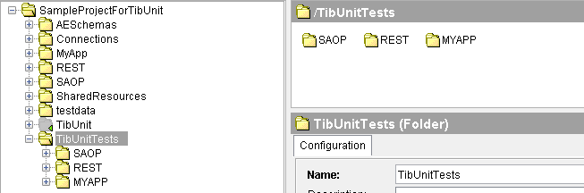

1. Created TibUnits by copying the sample test and adding implementation inside it. Calling the required processes which need to be tested, soap-request-reply to test soap project and send-http-request to test Rest service, and applied required asserts.

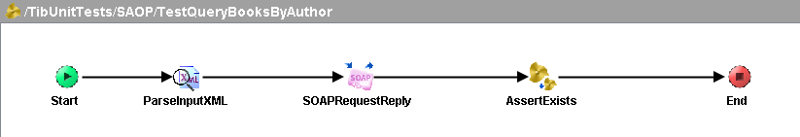

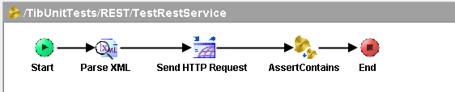

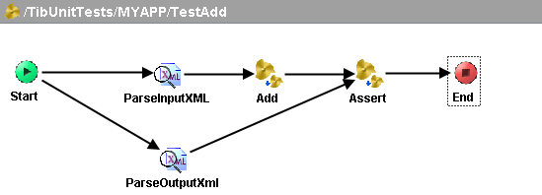

1. Provided the input and output files at the “testdata” folder created at step 5.

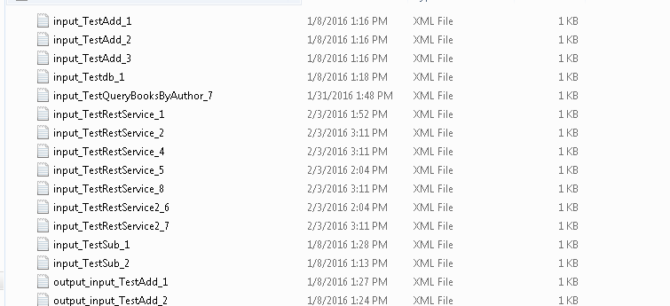

1. Started the tester with the required processes started.

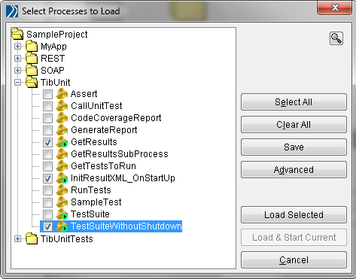

1. Went to “<http://localhost:8090/results>” in browser to see the report.

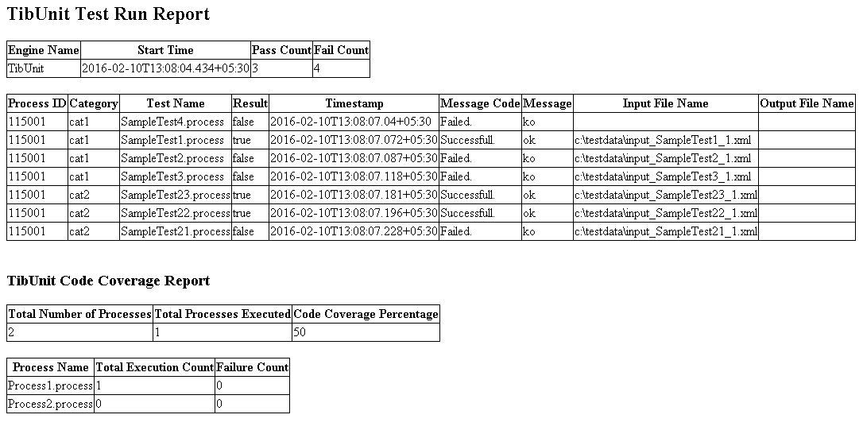

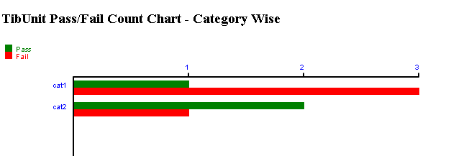

1. Checked the report file generated at the “report” folder created in step 5.

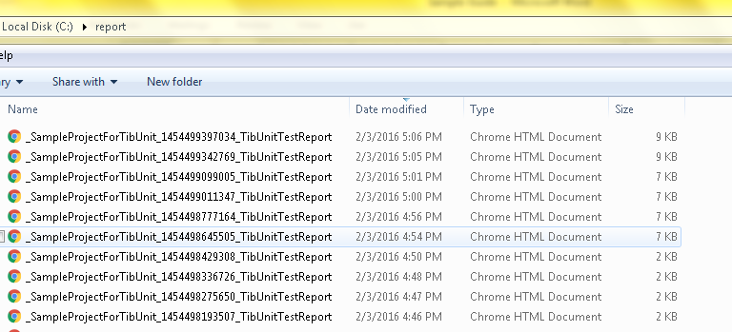

1. Checked the actual output files created for the failed test cases inside “testdata” folder created in step 5.

